At the September we love good food and drinks and many cuisines help us with our inspiration. With our regular tapas menu and seasonal specials, we will spoil you with dishes from just around the corner to the Greek coast. Our very extensive wine list will enable you to find a suitable wine for every dish. We hope you will enjoy our menu as much as we enjoyed creating it.

The Borrelplanken

Our luxuriously filled tapas boards consist of a selection of cold and warm elements from our tapas menu and are very suitable for people who can’t make a choice or who simply want to be surprised.

The Plank 24.5

The Bourgondier 37.5

LUNCH SANDWICHES TILL | 16:00
Roast Beef | 12.5
With poached egg, truffle mayo,
little gem
Prosciutto & Provolone | 11.5
With roasted sweet peppers, |  | 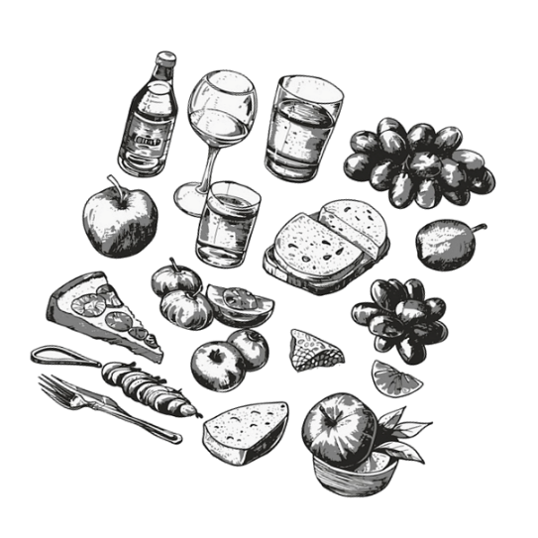
green tapenade, lettuce
Mackerel & Boeuf Tomato | 12.0
With pickled onion in balsamic
vinegar and lettuce
COLD TAPAS TILL | 00.00
Focaccia & Dips | 7.5
Focaccia made by Bro Bakery,
with aioli & truffle tapenade
Olives | 6.5 | Jamon Iberico | 12.0
Mix of Italian grapes |  | Thin cut Iberico ham, with
Sardines | 9.5 | cornichons & olive oil
Fish conserve van La Narval |  | 3 Times Cheese | 10.0
Mackerel, mussels, sardines, squid |  | Changing mix of Dutch, Spanish,
Burrata Di Bufala | 11.0 | France or Italian cheeses, served
With pomegranate molasses, |  | with figs & orange marmalade
arugula, tomato salsa % oil |  | Bruschetta Boeuff & Pecorino | 9.0
Rillette with pickled onion | 10.0 | Bruschetta with spicy-tomato
Of mackerel or procureur |  | salsa, fried capers & pecorino
WARM TAPAS TILL | 22.00
Chorizo | 13.0 | Mushrooms | 8.0
Backed chorizo sausages, honey |  | Marinated mushrooms in red wine
potato croutons, smoked peppers |  | sauce
Pulpo | 12.5 | Eggplant | 7.0
Soft octopus in tomato sauce, with |  | Roasted eggplant in garlic
olives & pickled onion in balsamic |  | smoked peppers and oil
Meatballs | 12.0 | Chicken Parmesan | 9.0
Homemade meatballs in truffle - |  | Chicken wings in tomato sauce,
gravy and mustard - mayonnaise |  | and parmesan cheese
Oysters Gratinée | 12.5 | Gamba’s | 13.0
3 gratinated oysters with parmesan |  | 5 Black tigers shrimps, green
bread and Pernod |  | Herbs in garlic oil
Crispy Focaccia & Anchovies | 8.5 | Manchego & Eggplant | 9.5
Focaccia with pesto oil, |  | Eggplant rolls filled with
and topped with anchovies |  | Manchego cheese and figs confit
TAPAS FRITTO TILL | 23.00
Shrimps | 9.0
Panko shrimps with aioli
Calamari’s | 9.0 | Fries | 8.0
Fried squid with spices |  | Fresh fries with spices, parmesan
And aioli |  | Cheese, homemade mayonnaise,
Beef meat croquets | 8.5 | green olive chipotle sauce
With mustard- mayo and spring |  | Sweet potato fries | 8.5
onion |  | With spices, parmesan cheese
King Oyster croquets | 8.5 | Spring onion and truffle mayo
With teriyaki – mayonnaise and |  | Pimentos De Padron | 7.5
Spring onions |  | Fried pimentos, with Maldon salt,
 |  | BBQ Sweet Chicagioo oil
 |  | Cheese Jalapenos Croquets | 8.5
 |  | With Chili- mayonnaise

